ArgoCD Sync Policy Labs - Hands-on UI Testing
Lab 1: Auto-Sync and Self-Heal Testing
Objective
Test ENABLE AUTO-SYNC and SELF HEAL options to understand automated synchronization and drift correction.
Prerequisites
- ArgoCD installed and accessible
- GitHub/GitLab repository with sample application
Setup Steps
Fork the repo to your account
https://github.com/amitopenwriteup/argoappsynclab.git
Map as source in your project

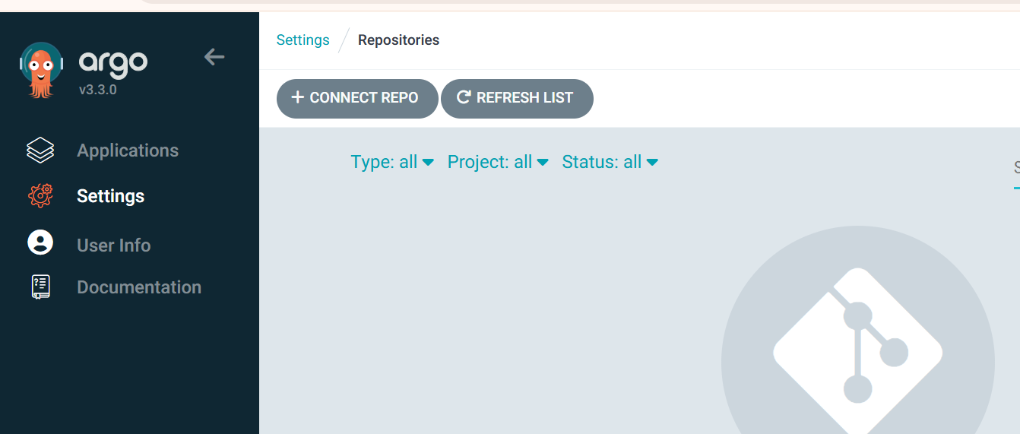
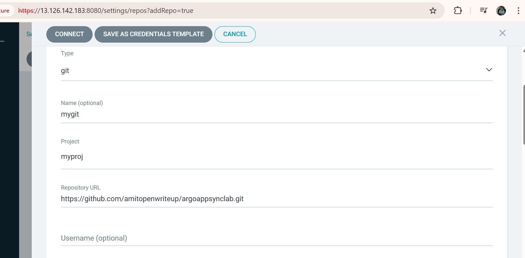

2. Create Application in ArgoCD UI
Navigate to ArgoCD UI:
- Click "+ NEW APP" button
- Fill in the following:
GENERAL:
- Application Name: lab1-autosync
- Project: myproj(Provide your project name)
- Sync Policy: Automatic
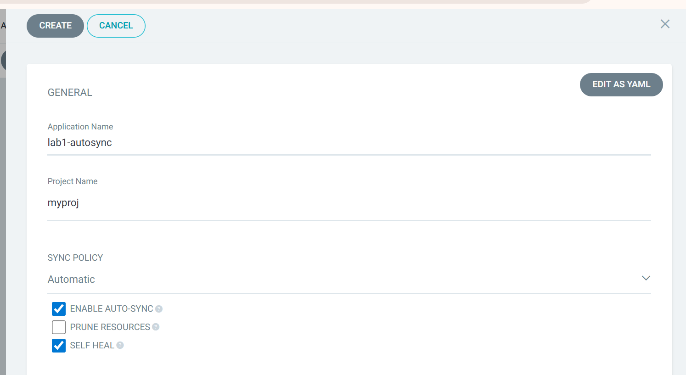
SOURCE:
- Repository URL: <YOUR_REPO_URL>
- Revision: HEAD
- Path: lab1-autosync
DESTINATION:
- Cluster URL: https://kubernetes.default.svc
- Namespace: leave it blank
SYNC POLICY Section:
- ✅ ENABLE AUTO-SYNC (check this box)
- ⬜ PRUNE RESOURCES (leave unchecked for now)
- ✅ SELF HEAL (check this box)
SYNC OPTIONS Section:
- ✅ AUTO-CREATE NAMESPACE (check this box)
- Click CREATE
3. Test Scenarios
Test 1: Auto-Sync on Git Changes
# Modify the deployment
Go to github.com repo and path lab1-autosync
Edit the deployment.yamlreplicas: 2 to replicas: 3

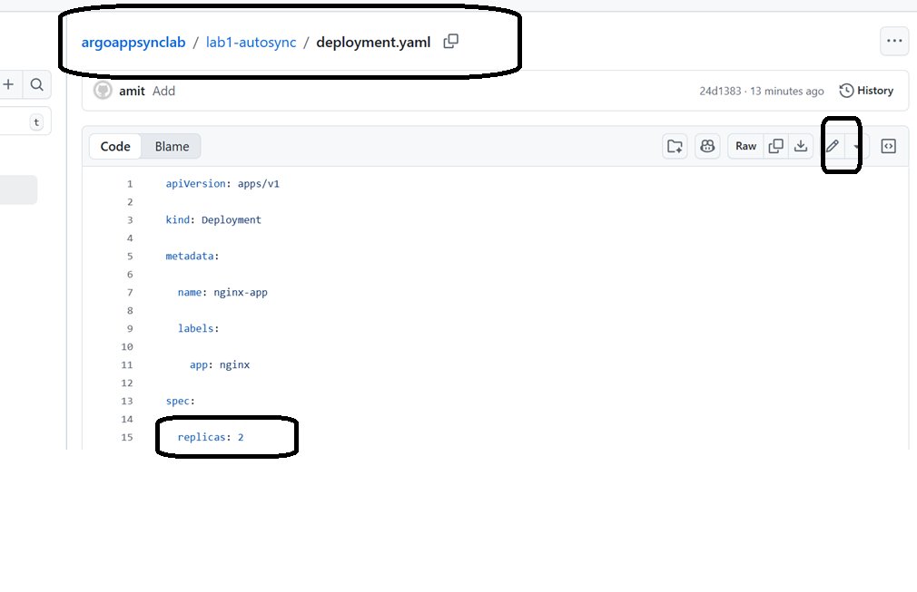

# Watch in ArgoCD UI
# The app should automatically sync within 3 minutes (default polling interval)
# You'll see the sync status change and replicas update
Observe in UI:
- Application will show "Syncing" status
- Progress bar will appear
- Once complete, status changes to "Synced" and "Healthy"

NOTE: IF require press Refresh
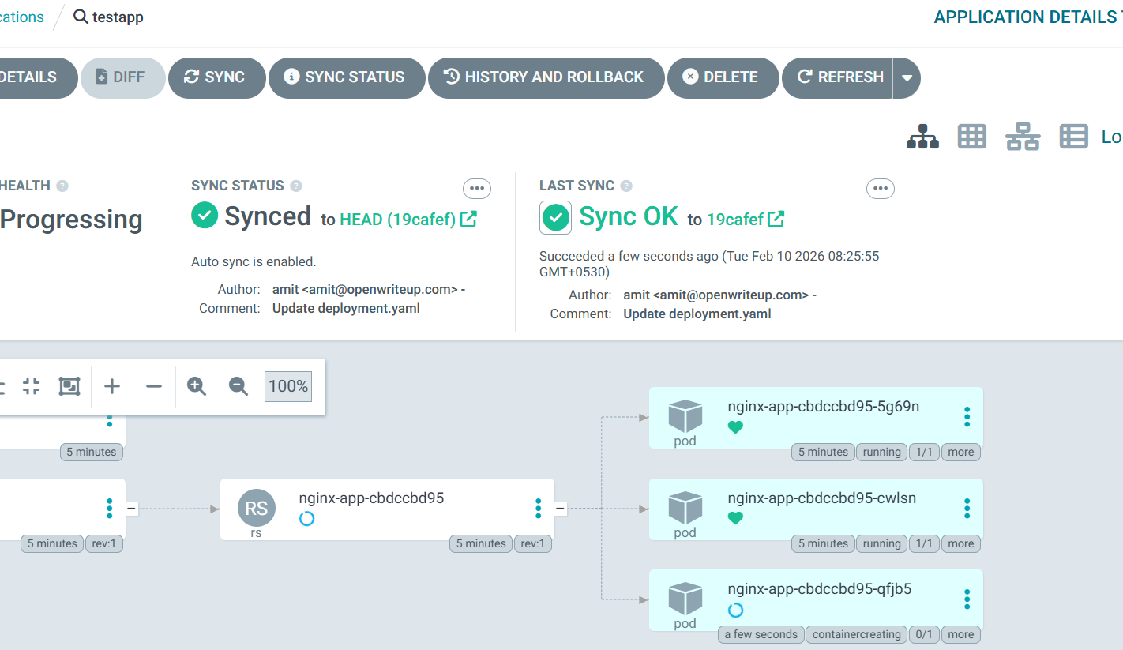

Test 2: Self-Heal - Manual Changes
# Manually modify the deployment in cluster
kubectl scale deployment nginx -n stage-nginx-namespace --replicas=5

# Watch what happens
kubectl get deployment nginx -n stage-nginx-namespace -w
Observe in UI:
- Application will show "OutOfSync" briefly
- Self-heal will trigger automatically
- Deployment will revert back to 3 replicas (as defined in Git)
- Status returns to "Synced"
Cleanup
# In ArgoCD UI
# Click on lab1-autosync → Click "DELETE" → Confirm

Lab 2: Prune Resources and Deletion Finalizer
Objective
Test PRUNE RESOURCES and SET DELETION FINALIZER to understand resource cleanup behavior.
Setup Steps
1. Create Application Repository
Same repo: lab2-prune
1. Create Application in ArgoCD UI
- Click "+ NEW APP"
GENERAL:
- Application Name: lab2-prune
- Project: myproj
- Sync Policy: Automatic
SOURCE:
- Repository URL: <YOUR_REPO_URL>
- Revision: HEAD
- Path: lab2-prune
DESTINATION:
- Cluster URL: https://kubernetes.default.svc
- Namespace: leave it blank
SYNC POLICY:
- ✅ ENABLE AUTO-SYNC
- ✅ PRUNE RESOURCES (check this box)
- ✅ SELF HEAL
- ✅ SET DELETION FINALIZER (check this box)
SYNC OPTIONS:
- ✅ AUTO-CREATE NAMESPACE
- Click CREATE
- Click SYNC to deploy
3. Test Scenarios
Test 1: Verify All Resources Created
kubectl get all -n stage-nginx-namespace

Test 2: Test Prune Resources
# Make sure you have configured ssh authentication for your github account
sudo su
ssh-keygen -t ed25519
#No need to provide keyname, just press enater
#No need to provide the passhrase, press enter two time
cat /root/.ssh/id_ed25519.pub
#copy the key
#go to github

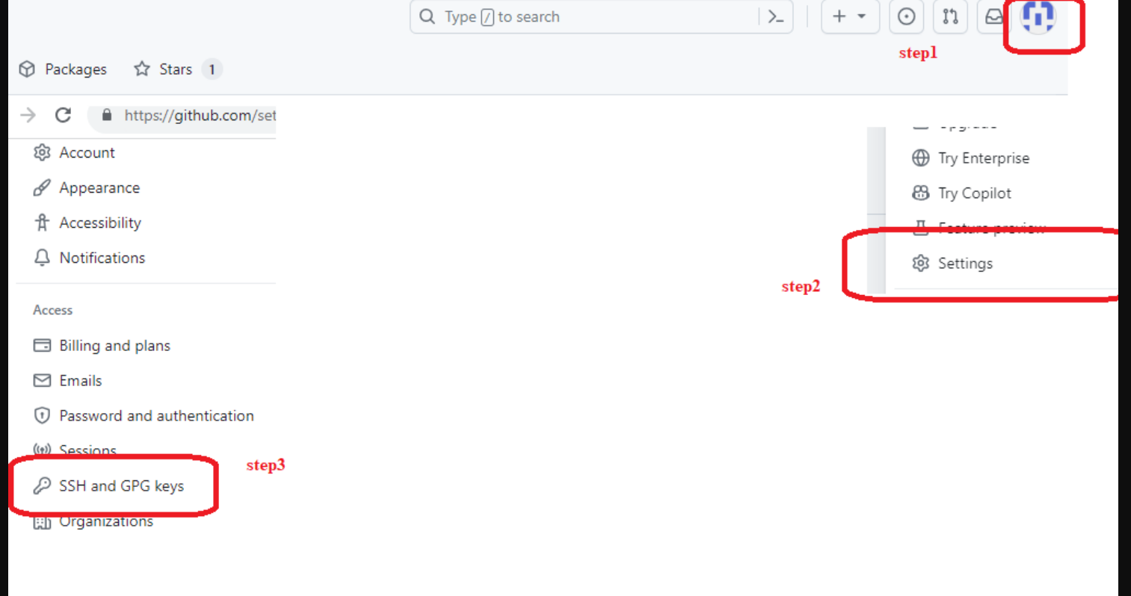

Copy the ssh url

#paste the key

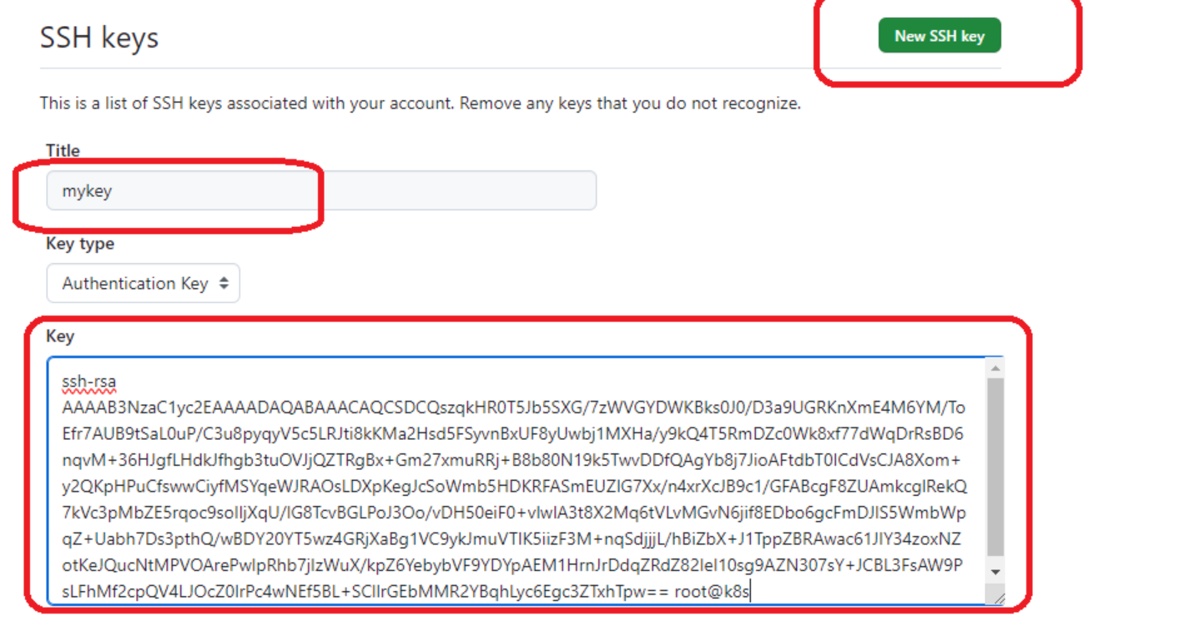

#Copy the ssh url
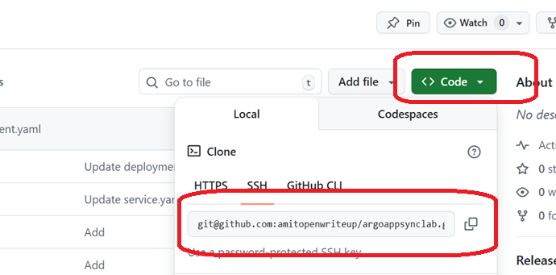

#Replace it with your url

git clone <your ssh url>
cd argoappsynclab/
cd lab2-prune/templates
# Remove the secret from Git
#Delete the configmap.yaml,from git repo
rm configmap.yaml
git add .
git commit -m "remove cm"
git push origin main
Observe in UI:
- ArgoCD will detect the change
- Auto-sync will trigger
- CM will be automatically deleted (pruned) from cluster
- Referesh page if require
- Application remains "Synced"
Test 3: Add Resource Back
# Restore the secret
git revert HEAD
#Press ctrl + X and enter
git push

Test 4: Test Deletion Finalizer
# Try to delete the application from UI
# Click on lab2-prune → Click "DELETE"
Observe in UI:
- Check the "Foreground" option
- Because we set deletion finalizer, you'll see cleanup happening
- The finalizer ensures proper cleanup

